First step, take suitable slice for the dataframe to locate the suitable data range,

Then use spIndexTrack function to construct the optimal portfolio to track the index,

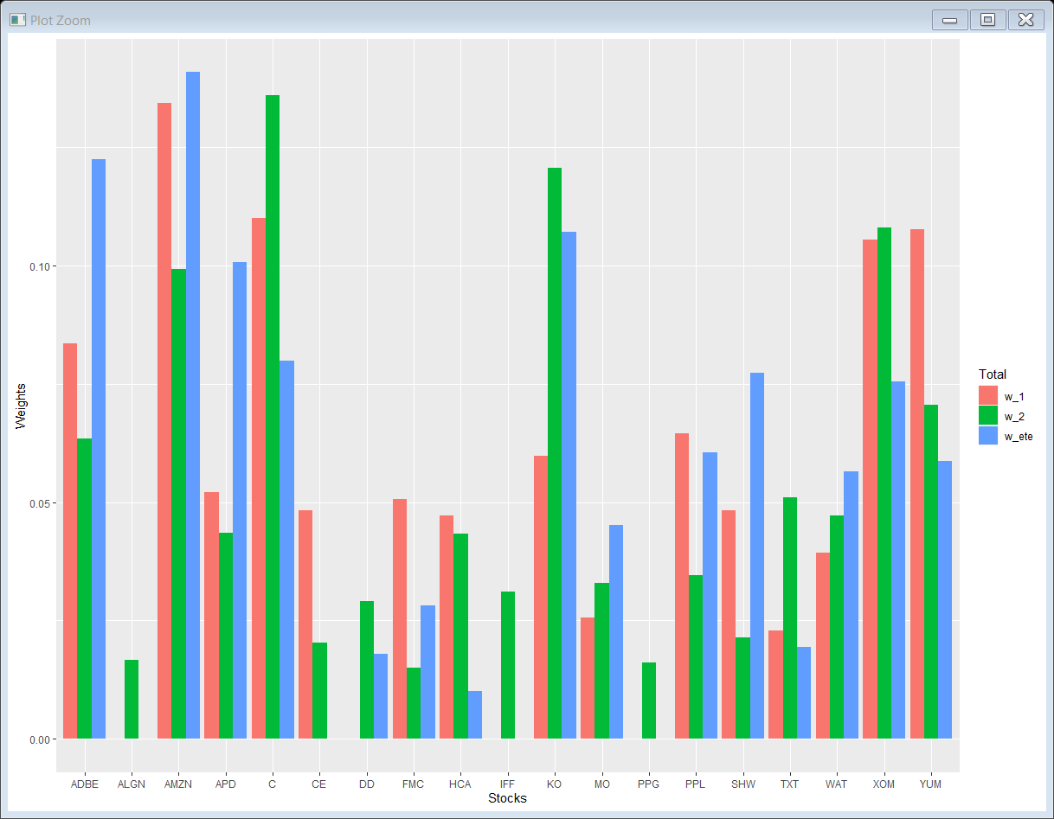

This bar plot shows how much weight the three portfolio put on each stock,

W_1 stands for using the data from 2019-01 to 2020-01 data

W_2 stands for using the data from 2017-01 to 2019-01 data

W_ete stands for using the whole data frame

Part b

Show how well does the portfolio perform to track the index

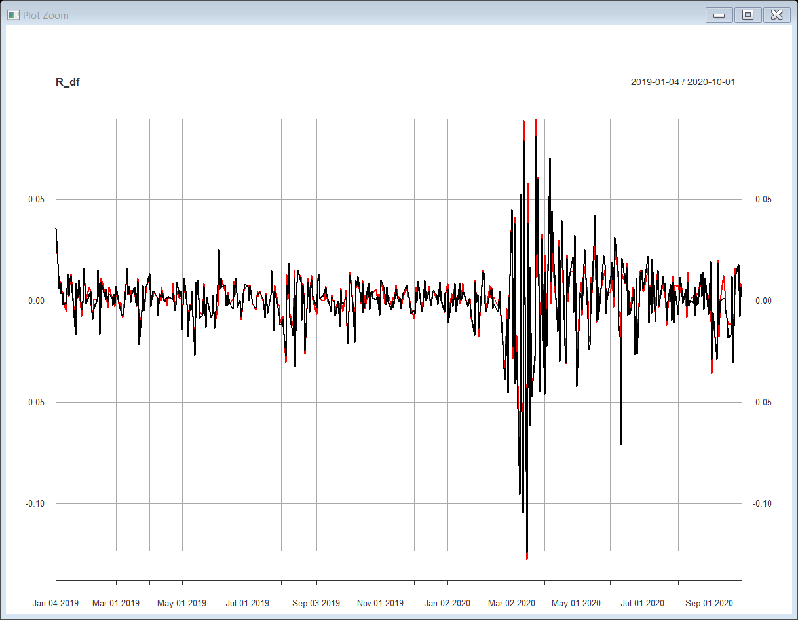

Red on is the W_2 performance, it seems mock very well except the 2020-03 to 2020-05 when the market is extreme volatile.

Use the std(diff) and 60-days window to check the performance quantitively.

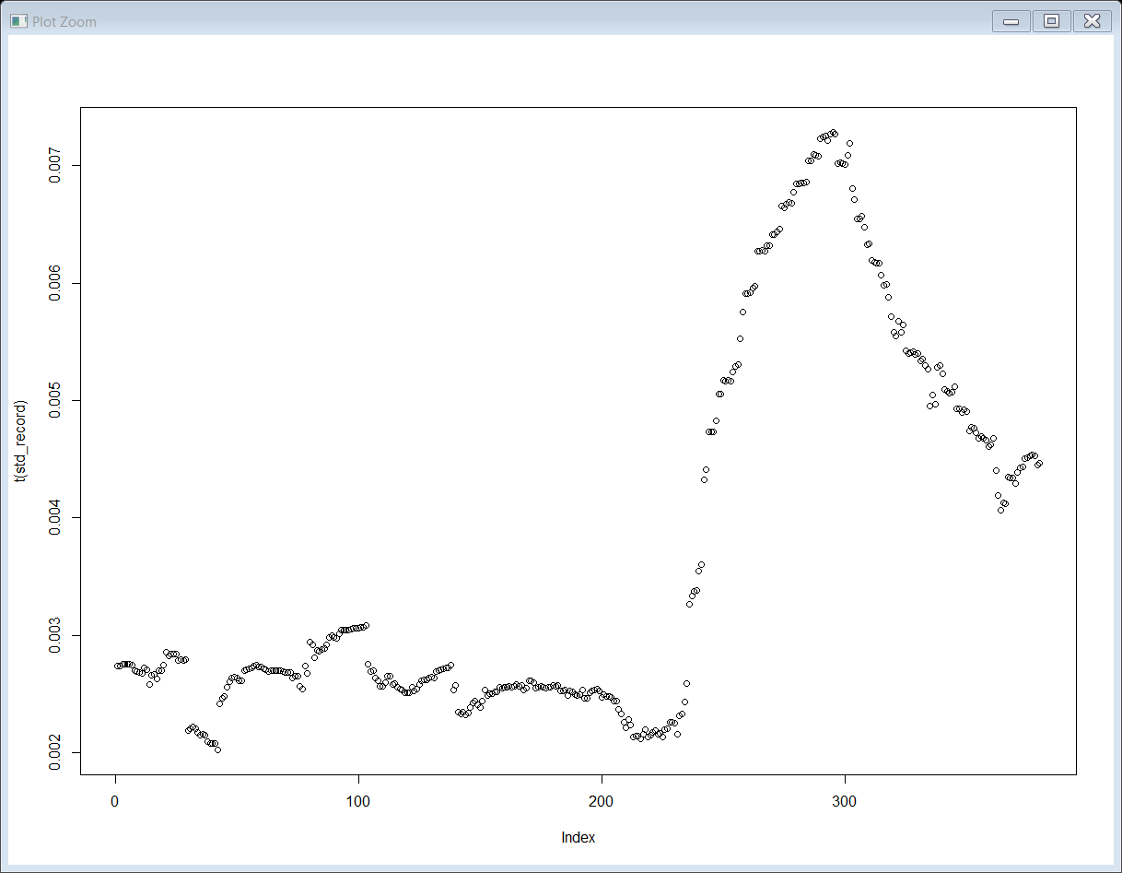

#the plot shows that the tracking performance at first 200 60-days window perform very well

#things changed a lot since 2019-12, the track error increased quite a lot and constructure a peak during 2019-12 to 2020-05

Use the most recent 1 year data to build w-1 to see whether it can perform better.

Use the monthly moving window to build error_m

The following one is the comparation between w_2 and w_1

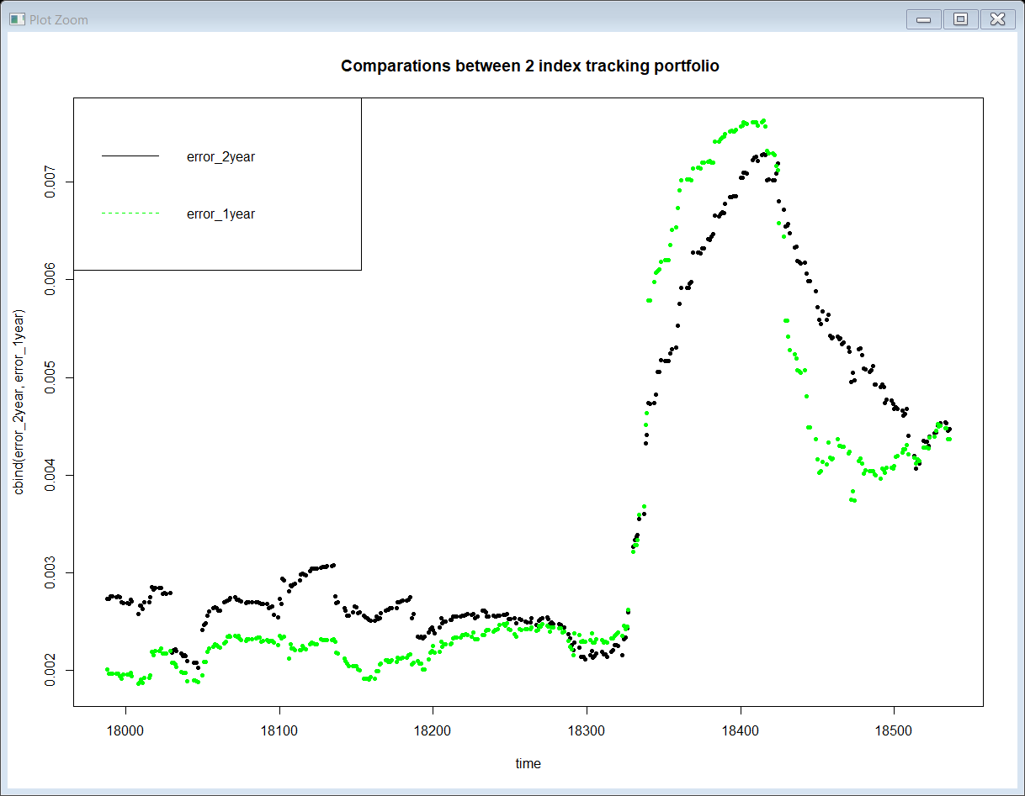

# we can observe that the new portfolio constructed by the most recent one year

# performs better during the first half period while it shows even worse result during the 2019-12 to 2020-04

# after that tracking error peak, the new portfolio again outperform than the previous one

This one is between error_monthly move and error of w_2

